Working With Dataset

# Exploration Of BP By Age

|  |  |
| --- | --- |
| Team ID | PNT2022TMID04535 |
| Project Name | Visualizing and Predicting Heart Diseases with an Interactive Dashboard |

## Dataset Link:

<https://www.kaggle.com/datasets/rishidamarla/heart-disease-prediction>.

## About Dataset:

This is a kaggle dataset. It contains 14 fields. The goal of the dataset is to predict the presence of heart disease.

## Exploration:

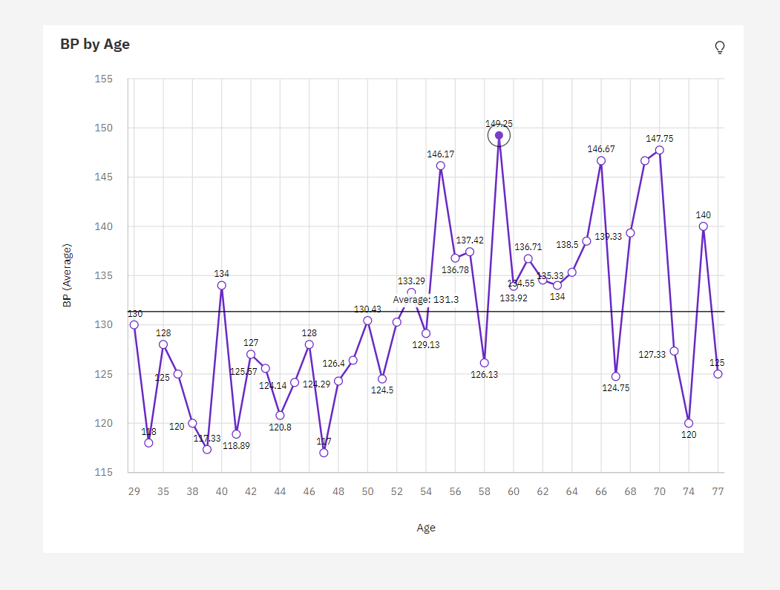

1. Over all **ages**, the average of **BP** is 131.3.
2. The average values of **BP** range from 117, occurring when **Age** is 47, to 149.2, when **Age** is 59.
3. **BP** is unusually high when **Age** is 59.
4. The most common values of Age are 54 (5.9 %) and 58 (5.6 %), together occurring 31 times, which is 11.5 % of the total.